HU Cloud Advanced Assignment
Question 1: EC2 Instance Creation and Management (AWS)
Find your default VPC and subnet
export AWS_REGION="us-east-2"
export VPC_ID=$(aws ec2 describe-vpcs \
--filters "Name=is-default,Values=true" \
--query "Vpcs[0].VpcId" \
--output text \
--region "$AWS_REGION")
export SUBNET_ID=$(aws ec2 describe-subnets \
--filters "Name=vpc-id,Values=$VPC_ID" \
--query "Subnets[0].SubnetId" \
--output text \
--region "$AWS_REGION")
echo "VPC ID: $VPC_ID"
echo "Subnet ID: $SUBNET_ID"
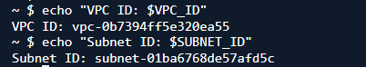
EC2 Instance Creation with CloudFormation
• Create an Amazon EC2 instance (t2.micro) using AWS CloudFormation.
Solution:->
- Find an Amazon Linux AMI
export AMI_ID=$(aws ssm get-parameter \
--name "/aws/service/ami-amazon-linux-latest/al2023-ami-kernel-default-x86_64" \
--query "Parameter.Value" \
--output text \
--region "$AWS_REGION")

echo "AMI ID: $AMI_ID"
AMI ID: ami-01c265752adadcdf8
- Create the CloudFormation template
cat > hu-devops-26-sburse-ec2.yaml <<'EOF'
AWSTemplateFormatVersion: '2010-09-09'
Description: Basic EC2 instance for HU DevOps assignment

Parameters:
VpcId:
Type: AWS::EC2::VPC::Id
Description: Select the VPC for the EC2 instance

SubnetId:
Type: AWS::EC2::Subnet::Id
Description: Select the subnet for the EC2 instance

AmiId:
Type: AWS::EC2::Image::Id
Description: Amazon Linux 2023 AMI ID

Resources:
BasicEC2Instance:
Type: AWS::EC2::Instance
Properties:
InstanceType: t2.micro
ImageId: !Ref AmiId
SubnetId: !Ref SubnetId
Tags:
- Key: Name
Value: hu-devops-26-sburse-ec2
- Key: HU_BATCH
Value: HU-DevOps-26
- Key: USER_NAME
Value: sburse

Outputs:
InstanceId:
Description: Created EC2 instance ID
Value: !Ref BasicEC2Instance

PrivateIpAddress:
Description: Private IP address of the EC2 instance
Value: !GetAtt BasicEC2Instance.PrivateIp
EOF

This command created a file named:
hu-devops-26-sburse-ec2.yaml
Check the template
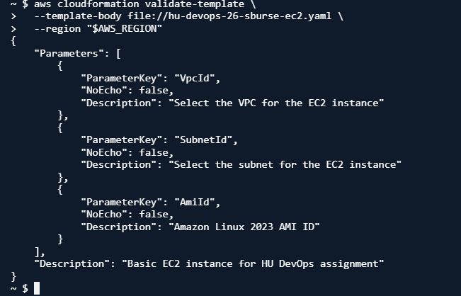

Create the CloudFormation stack
export STACK_NAME="hu-devops-26-sburse-ec2-stack"

aws cloudformation create-stack \
--stack-name "$STACK_NAME" \
--template-body file://hu-devops-26-sburse-ec2.yaml \
--parameters \
ParameterKey=VpcId,ParameterValue="$VPC_ID" \
ParameterKey=SubnetId,ParameterValue="$SUBNET_ID" \
ParameterKey=AmiId,ParameterValue="$AMI_ID" \
--tags \
Key=HU_BATCH,Value=HU-DevOps-26 \
Key=USER_NAME,Value=sburse \
--region "$AWS_REGION"
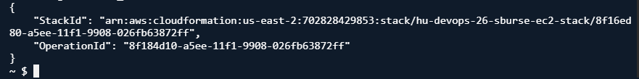
Wait for the instance to be created
aws cloudformation wait stack-create-complete \
--stack-name "$STACK_NAME" \
--region "$AWS_REGION"

echo "CloudFormation stack creation completed."
Check the result
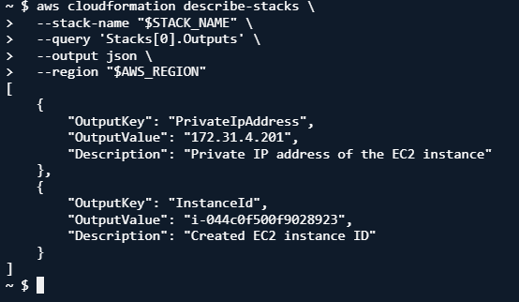

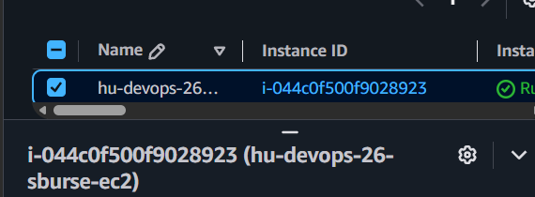

1.2 EC2 Instance Creation Using AWS CLI
• Launch a t2.micro EC2 instance using the AWS Command Line Interface (AWS CLI).
Launch the EC2 instance
export INSTANCE_ID=$(aws ec2 run-instances \
--image-id "$AMI_ID" \
--instance-type t2.micro \
--tag-specifications \
"ResourceType=instance,Tags=[{Key=Name,Value=hu-devops-26-sburse-cli-ec2},{Key=HU_BATCH,Value=HU-DevOps-26},{Key=USER_NAME,Value=sburse}]" \
--query "Instances[0].InstanceId" \
--output text \
--region "$AWS_REGION")

echo "Instance ID: $INSTANCE_ID"
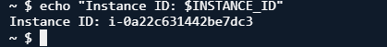

1.3 Automated Instance Configuration
• Use a user data script (Linux shell script) to install and start Nginx on the EC2 instance at launch.
• Set environment variables for configuration.
Create the user data script
cat > q1-3-user-data.sh <<'EOF'

dnf install -y nginx

export HU_BATCH="HU-DevOps-26"
export USER_NAME="sburse"
export APP_ENV="dev"

cat > /etc/profile.d/hu-devops.sh <<'PROFILE'
export HU_BATCH="HU-DevOps-26"
export USER_NAME="sburse"
export APP_ENV="dev"
PROFILE

cat > /usr/share/nginx/html/index.html <<'HTML'
<html>
<head>
<title>HU DevOps Nginx Server</title>
</head>
<body>
<h1>Nginx installed successfully</h1>
<p>HU_BATCH: HU-DevOps-26</p>
<p>USER_NAME: sburse</p>
<p>APP_ENV: dev</p>
</body>
</html>
HTML

systemctl enable nginx
systemctl start nginx
EOF

The command created a file named:
q1-3-user-data.sh

Launch the EC2 instance with user data

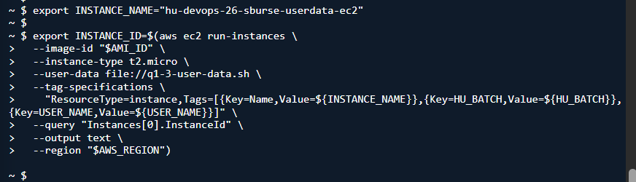

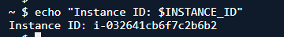

Question 2: ALB Creation with Proxy Methods and WAF (AWS)
(To be completed using the AWS CLI)
• Create an Application Load Balancer (ALB) and a target group for the EC2 instance.

• Configure a separate security group for the ALB to allow inbound HTTP traffic on port 80.
• Create proxy GET and POST methods using the Application Load Balancer URL.
• Ensure the proxy is configured to route traffic through a Web Application Firewall (WAF) that you
create.

